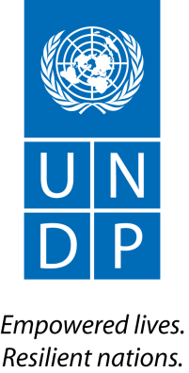
The Administrator

27 July 2015

Dear Colleagues,

Now that we are just past the 18-month marker for the implementation of UNDP’s Strategic Plan and Integrated Budget, it is imperative that UNDP units accelerate all efforts to meet the EGendorsed delivery targets for the achievement of the Strategic Plan, and its integrated results and resources framework (IRRF).

In this regard, the Executive Board approved UNDP’s integrated budget 2014-17 and its cost recovery policy, recognizing that eligible costs would be charged through ‘Direct Project Charging’
(DPC) mechanism to programme resources, covering Programme costs and Development Effectiveness (DE) costs. In the case of DE, the costs include (i) Programme policy advisory services; and (ii) Programme Pipeline development and management. These DE services in UNDP may be provided at country, regional and global levels. The expectation is that such services will be sourced internally. These should be directly reflected as fully costed project inputs in the respective programme/project budgets. This is essential to ensure high quality, efficient and effective delivery of development results, as well as to facilitate knowledge management.
Whilst some progress has been made in 2014 on DPC, progress needs to be accelerated. In this regard, Regional Bureaux should ensure that all country offices prepare roadmaps with concrete targets, so that the Bureaux can present an updated status on a regular basis to the EG. The POPP content is available to provide support and guidance. If further guidance is required, please consult with OFRM/BOM.

It is essential that relevant POPP guidance on the DPC methodology be followed, to ensure that DPC is applied across UNDP in a coherent, transparent, and consistent manner. Accordingly, I have instructed BOM to enhance monitoring mechanisms, including through the IRMF and Financial Reviews, to track progress. Going forward, the EG will closely monitor progress on implementing DPC. I look forward to marked progress in this area and count on your support.

Thank you,

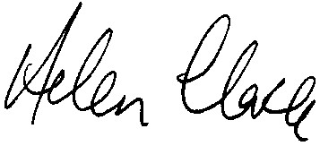
Helen Clark

To UNDP Assistant-Administrators and Regional Directors RBA, RBAS, RBAP, RBLAC, RBEC
One United Nations Plaza, New York, NY 100017 Tel: (212) 906 5791 Fax: (212) 906 5778 www.undp.org

